

CSA0501-DATABASE MANAGEMENT SYSTEMS

LAB EXPERIMENTS DATE: 20/07/2026

EXPERIMENT 7 – SELECT with GROUP BY, HAVING, ORDER BY
AIM: To view the records from the Pet Management System database using GROUP BY, HAVING, and ORDER BY clauses.
.
PROCEDURE:
• Open MySQL and select the pet_management database.
• Display all records from the pet_details table.
• Execute queries using the GROUP BY clause.
• Use the HAVING clause to filter grouped records.
• Sort the records using the ORDER BY clause.

• Verify the output and record the results.

PROGRAM:

1. Display all records:

USE pet_management;

SELECT * FROM pet_details;

OUTPUT:

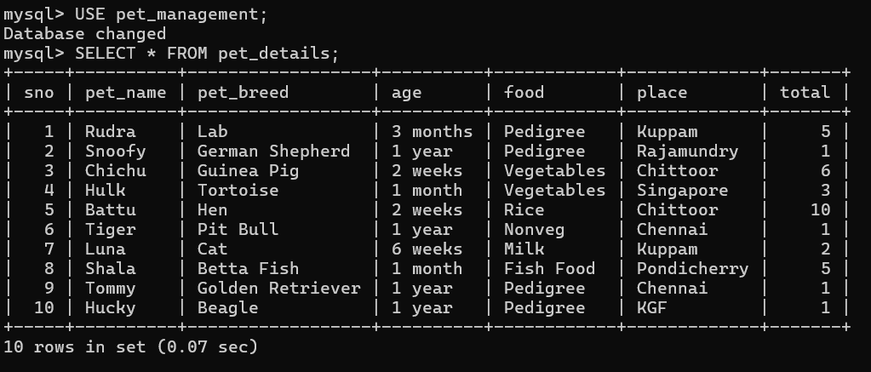

2. GROUP BY
Count the number of pets in each place
SELECT place, COUNT(*) AS Number_of_Pets
FROM pet_details
GROUP BY place;
OUTPUT:

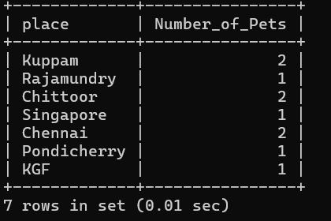

3. GROUP BY
SELECT food, COUNT(*) AS Number_of_Pets
FROM pet_details
GROUP BY food;
OUTPUT:

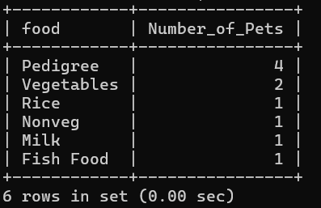
4. GROUP BY with HAVING
SELECT place, COUNT(*) AS Number_of_Pets
FROM pet_details
GROUP BY place
HAVING COUNT(*) > 1;
OUTPUT:

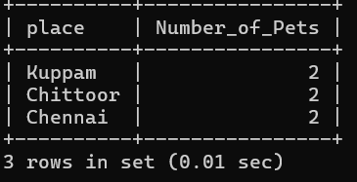

5. ORDER BY (Ascending)
SELECT * FROM pet_details
ORDER BY pet_name ASC;
OUTPUT:

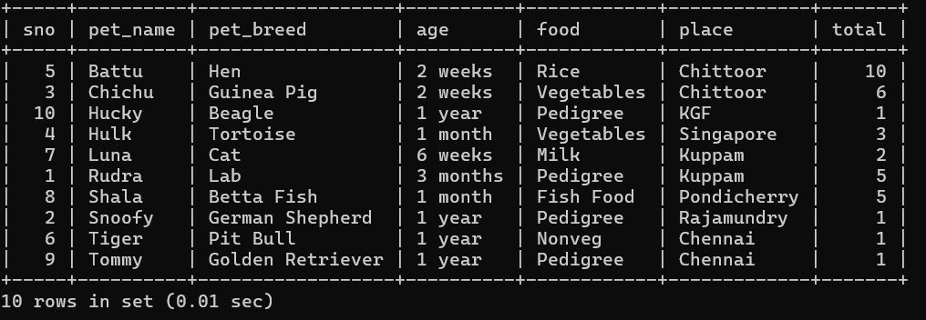
6. ORDER BY (Descending)
SELECT * FROM pet_details
ORDER BY total DESC;
OUTPUT:
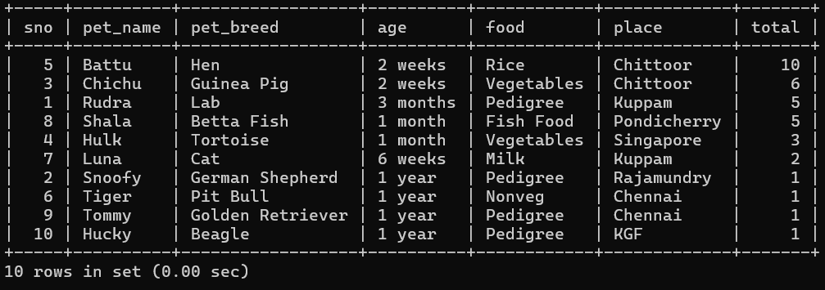

RESULT: The SELECT statements using GROUP BY, HAVING, and ORDER BY clauses were executed successfully. The required grouped, filtered, and sorted records were displayed correctly.

